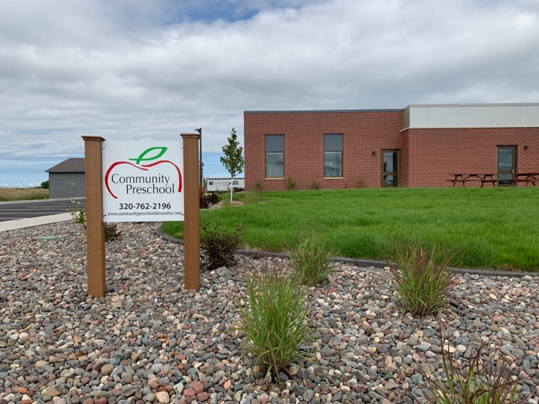**COMMUNITY PRESCHOOL**

**OF FIRST LUTHERAN CHURCH**

**1655 18th Ave. E. Alexandria, MN 56308  
320-762-2196**

**PARENT HANDBOOK**

**OUR PURPOSE**

The purpose of Community Preschool is to provide an early childhood social and educational experience for 3 to 5 year old children in a Christian atmosphere. It is owned and operated by First Lutheran Church as an outreach and ministry of the church to the Alexandria area in response to the needs of young children and their families. The teachers will serve as role models in Christian living, accepting everyone with love, care, and concern, with a goal of helping each child gain a positive sense of self-worth from the experience. Teachers will support parents and families by assisting with problems and concerns pertaining to their young children. Our program includes children with special needs. We work in conjunction with the support staff of District 206 as needed.

Community Preschool will also be available as a learning opportunity for older students in the area seeking knowledge in child development and care as a part of their education. It will have an advisory council consisting of people representing the community, First Lutheran Church, and the Church Vision Team.

**OUR GOALS**

The goal of Community Preschool is to enhance each child’s self-concept by stimulating his or her cognitive, social, emotional and physical development within a group environment. Children will be encouraged to experiment and explore*.* During playtime they will be free to choose their own individual or small group activities. At other times there will be more structured activities involving the entire class. These activities will be set up to help each child function within a group setting. Listening to others, taking turns, cooperating and sharing will be emphasized.

Throughout the sessions, each child will be encouraged to be responsible for his or her belongings, environment, and actions. Help will be available if it is needed, but children will be encouraged to do things for themselves *–* to become as independent as possible. Enjoyment of the arts will be promoted through songs, stories, art and craft activities, rhythm band and puppets. All activities are designed to give each child a happy first school experience, so that he or she will look forward to future years of education. Community Preschool of First Lutheran Church will accept children regardless of race, creed or religious affiliation.

**OUR STAFF**

COMMUNITY PRESCHOOL staff members are Melisa Schueler, Randi Rach, Angela Hughes, Helen Maier, and Angie Carstensen. The director and teachers are state licensed and have college degrees in education or early childhood endorsements. All staff members have current certification of CPR and First Aid training, in addition to annual continuing education classes and workshops pertaining to young children and their concerns. Occasionally there are child development and nursing students from the ATCC completing their child development requirements.

**OUR FEES**

COMMUNITY PRESCHOOL is a non-profit facility and is supported by tuition received. Along with monthly tuition, a one-time registration fee and supply fee are collected. No statements will be sent, but a ***tuition envelope*** with a record of payments will be sent home monthly. Your payment may be sent to school with your child in the tuition envelope. Tuition is due by the 15th of each month. Please make checks payable to Community Preschool. Families wishing to pay for the entire year or several months in advance are welcome to do so. Community Preschool is constantly seeking out new and creative ways to keep our tuition costs down.

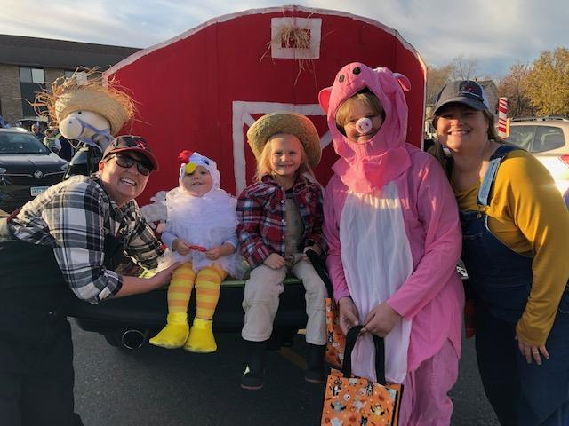

It is our policy that if a child is not picked up within 15 minutes of dismissal time, a late fee will be charged, unless special arrangements have been made ahead of time. The fee is $15 for pick up after 11:45 AM and 3:30 PM for classes in the 4 & 5 year old room and 11:35 AM in the 3 & 4 year old room that the Community Preschool staff is responsible for your child. That time is scheduled for staff planning, preparation, clean-up and lunch break.

** OUR CALENDAR FOR THE YEAR**

The school year begins with a Parent Information Meeting OR an Open House in Aug/Sep.   
Orientation Conferences are held in early September.   
Parent-Teacher conferences are in November and the Spring Conferences are in March/April. Classes are in session from the day after Labor Day to the week before Memorial Day*.*

You can print the yearly calendar from our website: communitypreschoolalexandria.com

Last minute cancellations due to weather will be announced on local radio stations as well as TV stations. We follow District 206 weather advisories. If District 206 is closed, Community Preschool is also closed. If District 206 is delayed 2 hours, our morning class will be cancelled…however an afternoon class would still be in session as scheduled. If District 206 announces an early dismissal, our afternoon class will also be dismissed or cancelled.

**COMING AND GOING**

For children in a morning class we offer before school care beginning at 7:30 a.m. Please walk your child into the classroom. Children may eat breakfast at home or bring their breakfast to school.  We have a special table used only for eating together. This program is held in the Sunshine Room. This can be used on as needed basis. No previous notice necessary. Cost is $4 per time.

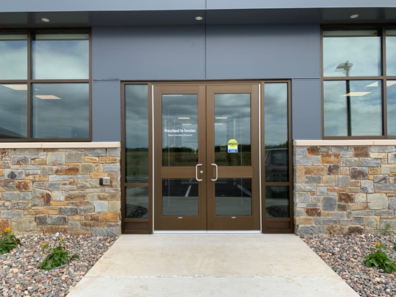

*If you are not using Breakfast Buddies,   
PLEASE DO NOT BRING YOUR CHILD TO SCHOOL BEFORE 8:05am for the 3 and 4 year old class*

*8:15am for the 4 and 5 year old class*

*12:15pm for the afternoon classes*

Before that time is staff preparation and lunch time. There will be a staff member at the door when it is time to come in.

***IF YOU DON’T SEE A STAFF MEMBER AT THE DOOR, PLEASE DO NOT LEAVE YOUR CHILD WITHOUT CHECKING TO SEE THAT A STAFF MEMBER IS IN THE ROOM!***

We will bring the children to the preschool door at dismissal time:   
11:20 morning class in the 3 & 4 year old room  
11:30 AM for the morning class in the 4 & 5 year old room

3:15 PM for the afternoon class in the 3-5 year old room

For the safety of the children, we ask that you come to the sidewalk to pick your child up

and indicate to a staff member that you are assuming responsibility for him or her.

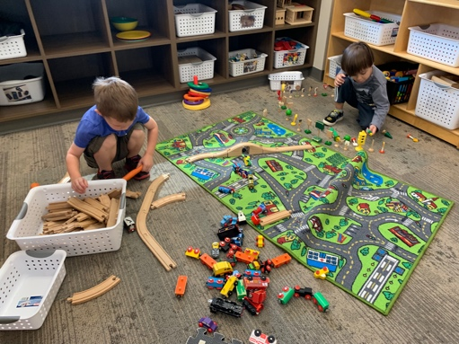**OUR DAILY SCHEDULE**

In our daily schedule we include free play, books, creative art, gross motor, fine motor, music, snack, and activities that allow for exploration and use of open-ended and imaginative play. The schedules are flexible to take advantage of experiences that come up from which the children might benefit and to fit the personality and needs of the class. When time and weather permit, some activities will be shortened to allow for outdoor play, typically at the end of the session.

**CLOTHING**

Dress your child in ***play clothes*** that they are comfortable wearing. We want them to be able to play and explore without the worry of getting something on their outfit. Consider clothing’s “ease of use” in their independence using the bathroom. (Belts can be tricky if you are in a hurry.)

Be aware that some of our art mediums may not wash out of clothing. Tennis or other fastened type shoes work best for our active program. Flip flops and sandals often get wood chips from the playground in them, or they are uncomfortable during walks or outdoor play. Please label all outer clothing with your child’s name or initials to avoid mix-ups.

Please send boots and snow pants in a separate plastic bag daily so the children will still have room in their school bag for important mail and schoolwork. If winter weather permits us to safely play outside, we will. Remember to also label each boot and mitten with initials so we know who they belong to.

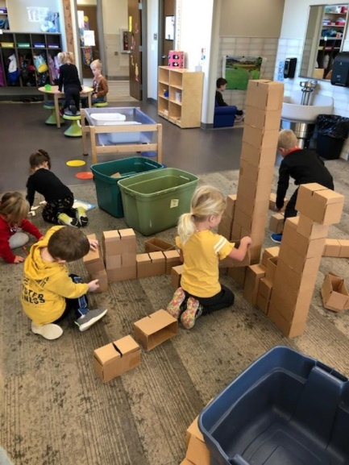Children are encouraged to dress themselves, so please be sure outerwear can be put on easily. Mittens work much  
better than gloves.

**SHOW & TELL / SHARING BAGS**

Your child will have many opportunities to bring one item from home in a sharing bag. This encourages language development and builds confidence. At times the bag may have a tag with a theme we are following and we ask you to help the child find something pertaining to that theme. Please send this bag to school in their school bag on the next school day.

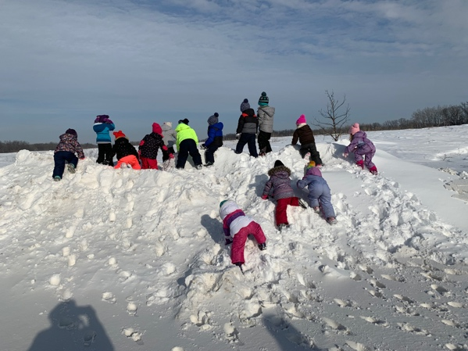

**PLAYTIME**

It is often said that “play is a child’s work.” Brain studies in children have shown that when children are playing and active their brains are developing and growing. During free play time children are free to choose what they would like to play with and to change activities and playmates at will. During this time there are art experiences available as well as science, dramatic play centers and other areas and objects to explore and manipulate. For the safety of all there is no weapon play or other aggressive play allowed. Weather permitting, we will go outside to play on our playground. Please have the children wear shoes that are closed (tennis shoes) to avoid wood chips from hurting their feet when we’re on the playground or going for a walk.

**BEHAVIOR GUIDANCE**

The goal of our preschool is to help children distinguish between desirable and undesirable behavior and to help them in choosing appropriate actions. Positive reinforcement is used to help children make good decisions. Teachers model appropriate language to help children gain the social/emotional skills needed when in a group setting.

If an undesirable behavior continues and alternative guidance is not helping, the child will be asked to come to a table in the room and given a book or puzzle to redirect them. The teacher will talk to the child about their behavior and what would be a good alternative. No physical punishment is ever used. Communication regarding a child’s behavior will be discussed as necessary with parents.

MC900264300[1]

**BIRTHDAYS – SNACKS**

Children are very important people and so are their birthdays! To celebrate their special day, they may bring a snack to school for all their friends to share. About a week before you will receive information about when to send birthday treats. Some ideas for snacks for birthdays or anytime of the year are Rice Krispie treats, fruits (ready to eat), veggies (ready to eat), crackers, fruit shapes or roll-ups etc.

Licensing requires that snacks be purchased at a store. If your child has a summer birthday, we will celebrate their ½ birthday.

Please check with the teacher if you would like to bring a perishable snack to be sure there isn’t a snack already planned for that day.

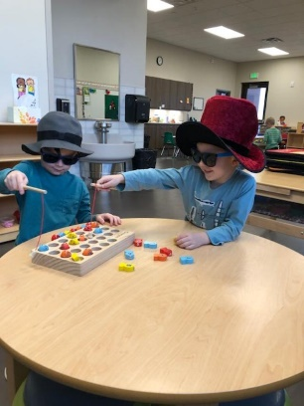

**CLASSROOM HELPERS**

The children will have many chances to be helpers in the class. They will have a simple job to do such as checking the weather and calendar. They may mention that they were a helper that day and you could ask them to tell you about it.

**ART ACTIVITIES**

To encourage creativity and exploration we give the children many different art mediums. To a child, it’s all about the process, not the product. When they bring something home it may be helpful to ask them to tell you about it or admire the colors or shapes, they used. This gives them pride in their effort and encourages them to create again!

For the child to enjoy the whole process of creative art, please send them to school in clothes that you don’t mind coming home dirty.

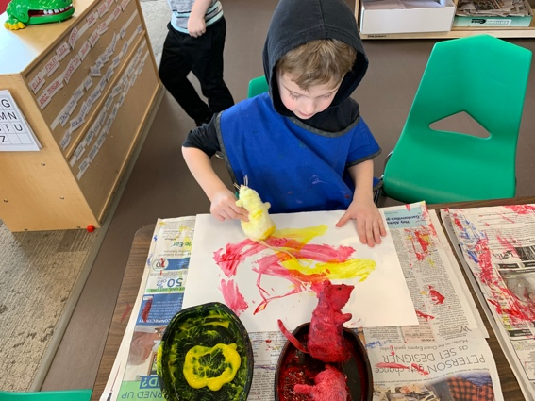

**ADULT HELP IN THE CLASS**

During our school year we may need an extra hand. We appreciate parents and other adults who may help on a special day, such as going along on a field trip, helping the teacher with a special project, etc. At Community Preschool we have an open-door policy, so if you have a day off of work and would like to come in, please come. The teachers will put you to work.

VISITORS

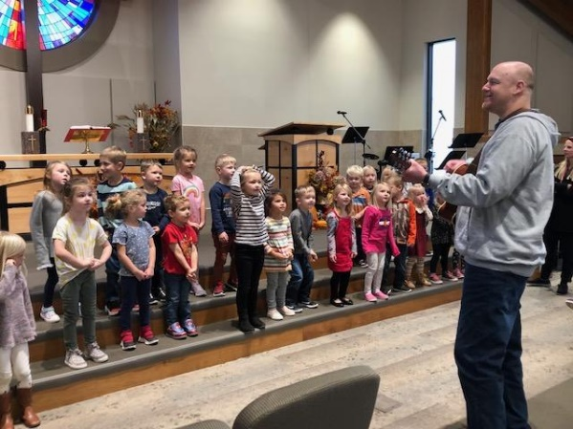

Pastor PJ

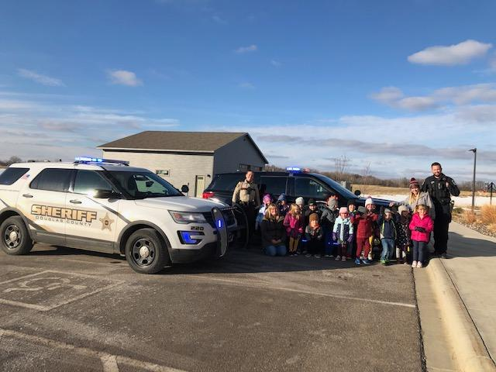

ALEXANDRIA POLICE OFFICER

DOUGLAS COUNTY DEPUTY

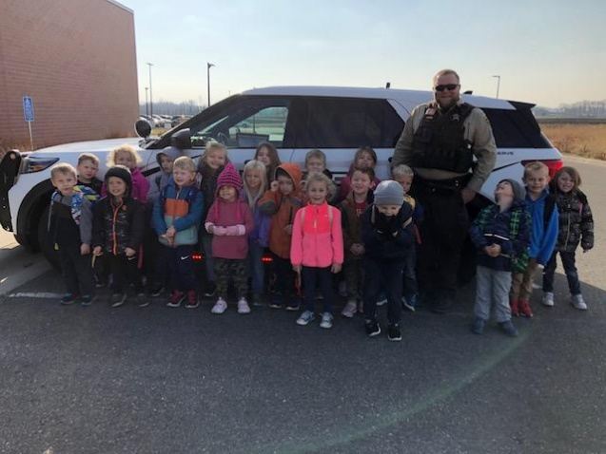



**Policies for Parents**

1.Community Preschool of First Lutheran Church is a preschool program licensed by the Minnesota Department of Human Services, Division of Licensing (651-431-6500) and conducted by state certified teachers. It is a non-profit organization, owned and operated by First Lutheran Church. It is designed to foster the social, emotional, intellectual and physical development of each child through a variety of activities, both structured and unstructured, as stated in its goal. Parents may obtain more detailed information on the facility’s child care plan by contacting the director.

2. The program is licensed for 40 children and will be in operation from Labor Day to Memorial Day with the following schedule:

**3 year olds** **4 & 5 year olds**

MW 8:05 – 11:20 am MWF 8:15 – 11:30 am

TTh 8:05 – 11:20 am TTh 8:15 – 11:30 am

MW(Th) 12:15 – 3:15 pm combined with MWTh 12:15 – 3:15 pm

Fri 8:05 – 11:20 am

There can be an option for a ½ day class for young 3’s (children who are potty-trained and are   
two years old by January 1st) as necessary.

3. Children should be three or four years old by September first of the year they enroll for a class.

4. The fees are set each year before registration for the following year by the Advisory Board.

5. Transportation to and from school is the responsibility of the parent. Class lists will be available for anyone wishing to arrange carpools if parents have given permission for Community Preschool to share their contact information.

6. Personal items brought to school should be marked with the child’s name or initials. We are not responsible for items brought to school and prefer that valuable or breakable items be left at home.

7. A snack will be served midway through each session. Generally, it will be milk and a nutritious food item. Children may bring treats to share providing they are store bought and they bring enough for each child in their class. Popcorn and hard candy will not be served.

8. The preschool does not have special facilities or staff to accommodate children with special needs. If a child with special needs wishes to enroll efforts will be made to work with the ECSE program of District 206. Information must be obtained from the parent, the child’s physician, and state or local agencies that may be involved in special problems the child may have. If the teacher and director determine that the child could participate in the program, an individual education or childcare program plan must be developed by the parents and teachers or obtained from an agency involved. The plan must be in writing and evaluated annually.

9. Insurance coverage on the children will be more than $100,000/$300,000 for general liability.

10. The preschool will not discriminate in admissions or demissions on the basis of race, sex, religion, creed, color, national origin, or source of payment. Teachers shall be Christians, and parents can expect a Christian attitude and lifestyle demonstrated in the classroom. Teachers shall be free to speak of Jesus and the Gospel.

11. An orientation conference in which the parents and children meet the teacher and assistant and see the facility shall be scheduled before the child begins the program. Two parent/teacher conferences shall be scheduled during the school year for each child. A written report concerning the child’s social, emotional, physical and intellectual progress will be sent home in the spring.

12. Parent permission allowing a child to go on field trips will be obtained on a form signed by the parent when a child enrolls. The same procedure will be used to obtain permission for a child to participate in any research or public relations activities should they occur. Information concerning these activities will be available in the monthly newsletter, a preschool memo or phone call.

13. Parents will be encouraged to visit anytime, help in the classroom, call if they have questions or suggestions, and share their talents, interests, and experiences with the classes.

14. Animals brought to school must be properly cared for, inoculated and licensed, and shall be leashed, caged, or otherwise under control. Parents will be informed of pets residing at school.

15. The center shall require the parent to submit a health statement signed by the child’s source of medical care and a record of immunizations before a child is admitted to preschool. Immunizations must be up to date within 15 days of enrollment.

16. If a child becomes ill or injured while at school an effort will be made to contact the parents by phone to come and pick the child up. If a parent cannot be reached, a call will be made to the names listed on the emergency contact form for a person who has permission to care for the child. A sick child will be made comfortable, apart from the group activity but in a room where he or she may be observed by the teacher or director. In the case of injury, the staff will administer first aid if the injury is judged to be such that the child will benefit.

17. Children will be excluded from school if they are running a fever, vomiting, having diarrhea or respiratory distress, coughing or sneezing excessively, have an untreated bacterial infection or an undiagnosed, untreated or contagious rash, chickenpox, ringworm, impetigo, lice, scabies, or show COVID 19 symptoms. Children with chickenpox shall be excluded until they are no longer infected, and the lesions are crusted over. A child with unexplained lethargy or who is not able to participate in activities with reasonable comfort or who requires more care than the staff can provide shall also be excluded. Parents of children who are absent because of illness should call the preschool and report symptoms the child is having. Parents will be notified of any contagious illnesses reported in their child’s classroom.

18. The staff will administer medications only when a child’s health is in jeopardy without the medication. The parent must give written permission on a form provided by the preschool for the drug to be administered. The medication must be in its original container with the pharmacy label attached and legible.

19. If a child has a communicable or infectious disease, the parent should inform the center within 24 hours of diagnosis so the teacher can inform parents of other children who may have been exposed.

20. The Alomere Emergency Room shall be the center’s source of Emergency Medical Care. Parents of the child shall be notified and North Ambulance Douglas County shall be called to transport the child to the hospital.

21. In general, behavior guidance shall consist of redirecting the child or talking to the child about the problem. Only if these methods are unsuccessful, separation from the group may be used. The child will be within sight and hearing of an adult and will be returned to the group when the behavior is under control. All separations shall be noted in a daily log. No child shall be subjected to corporal or psychological abuse by the staff. A more detailed Behavior Guidance Policy is available for review at parent request.

22. If weather conditions force District 206 to close, Community Preschool will not be in session. In general, if road conditions force District 206 to open two hours late, the morning preschool session will be cancelled. (One hour changes will not affect preschool). The local radio stations carry District 206 announcements.

**Emergency procedures are as follows:**

**Fire Evacuation**: Remove the children from the building by the primary or secondary exits depending on fire location (see emergency evacuation map posted in each classroom). The teacher will take out the first aid kit, cell phone and emergency cards. Our emergency shelter is the playground or church garage.

**Tornado or Blizzard:** Each classroom will dismiss to the hallway closest to their classroom and proceed to the nursery/bathrooms in the center of the building. The children will sit on the floor and cover their heads as required. A battery-operated radio and flashlight will be available for use.

**Utility Failure:** Each classroom has a flashlight and each room has emergency lighting. Our emergency shelter is the playground or church garage next to the preschool wing of the church.

**Missing Children:** Search the building and grounds, notify police with a full description of child, then notify parents.

**Missing Parent:** If unable to reach parents or emergency contacts within one hour of dismissal time, police may be notified.

**Grievance Procedure:**

The following process should be followed if a person has a complaint or grievance about an occurrence at Community Preschool:

* An informal attempt should be made to resolve the matter with the person who can effect a change in the situation.
* If the attempt is unsuccessful, the complaint should be put in written form and taken to the director within one week of when the alleged offense occurred.
* The director will respond to the complaint as soon as possible.
* If the matter remains unresolved, the complainant should take the written complaint and all written correspondence concerning the complaint, to the Community Preschool Advisory Council.
* Any issues that remain unresolved after this procedure should be taken to the First Lutheran Church Council.
* The party with the complaint will be notified as soon as possible after a Community Preschool Advisory Council or First Lutheran Council meeting - what, if any, action will be taken because of the grievance.

**STAFF CONTACT NUMBERS**

Community Preschool Office: Melisa Schueler (320) 762-2196 (First Lutheran Church)

Director/Teacher: Melisa Schueler (320) 219-8640 (cell)

Teacher: Randi Rach (320) 491-1153 (cell)

Teacher: Angela Hughes (218) 686-8116 (cell)